`

Prototyping Tutorial

Prototype a new fitness app, FindATrail:

FindATrail will be a fitness app used for finding outdoor activities such as walking, hiking, and climbing. The app will allow users to access a database of trail maps. Your group needs to prototype a mobile app and a web app.

- Have a look at other similar apps e.g., AllTrails for inspiration.

- Identify the scenario that you are going to prototype.

- Create a comprehensive paper prototype or digital prototype of this app (a storyboard, or screen prototypes of your system) – for both the mobile and web app for the scenario you have identified in Q2. There should be approx. 3 images for each prototype.

- Create a wireframe for the home page for both the mobile and the desktop prototype.

- Upload a zipped folder with the following to Brightspace to the assignment “Find a Trail – in groups”:
  - A word document with a short description of your app and the scenario you have chosen to prototype.
  - Images from the Mobile prototype (there should be approx 3 images).
  - Images from the Desktop prototype (there should be approx 3 images).
  - A picture of both wireframes.
Ensure all group members have a copy of everything uploaded as you need it for your lab.

There are NO marks assigned to this.
fitness app:
-finding outdoor activities
walking,
hiking,
climbing,
etc.
-user must be able to access a database of trail maps
- prototye mobile app and web app

- Review of AllTrails for inspiration:
Search over 100000 trails with trail info, maps, detailed reviews, and photos curated by millions of hikers, campers, and nature lovers like you.

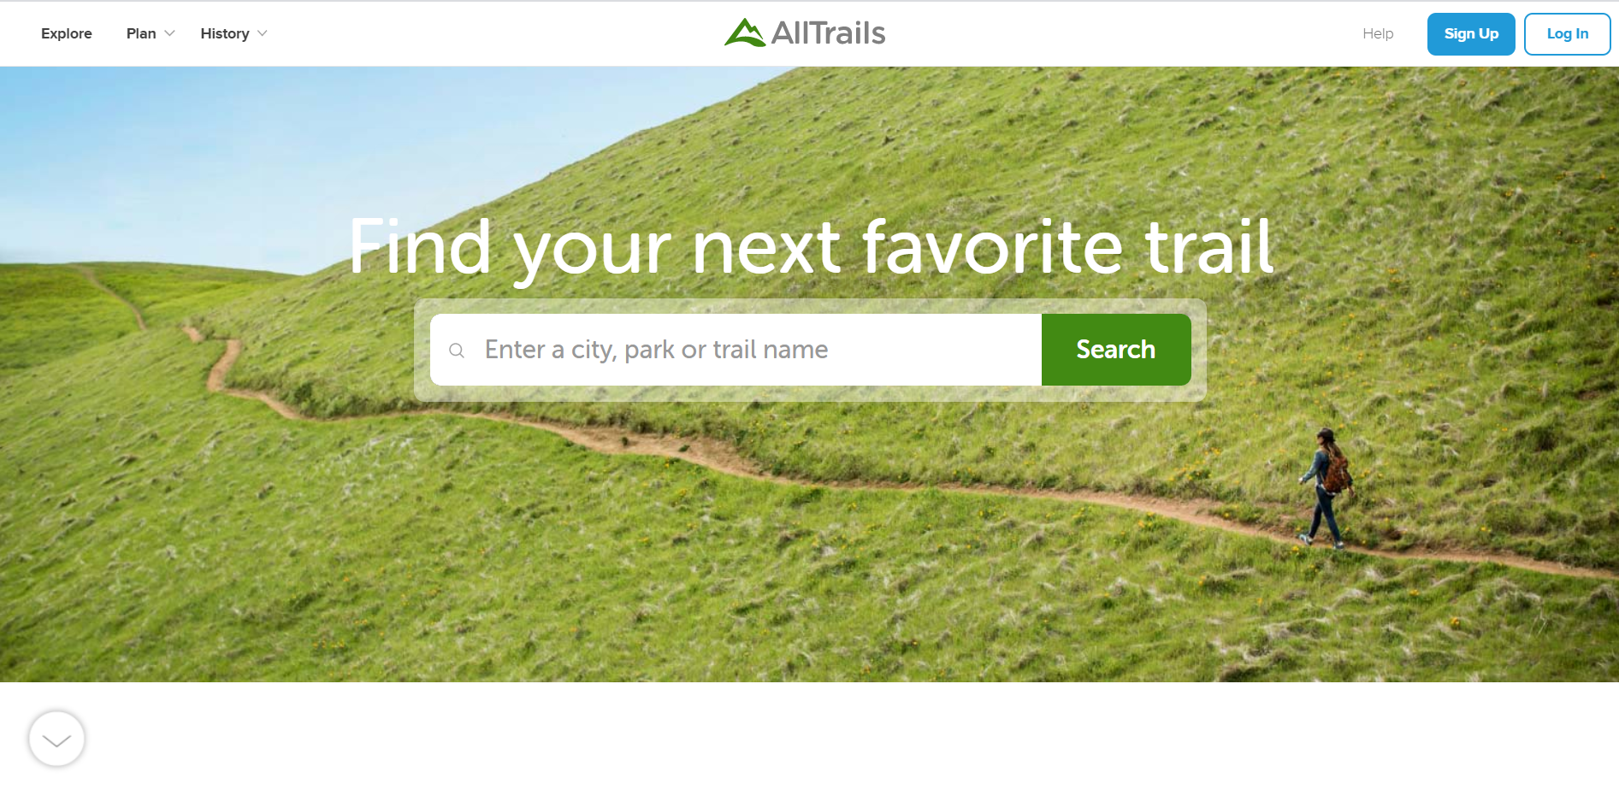
Web view of alltrails


Wireframe of alltrails

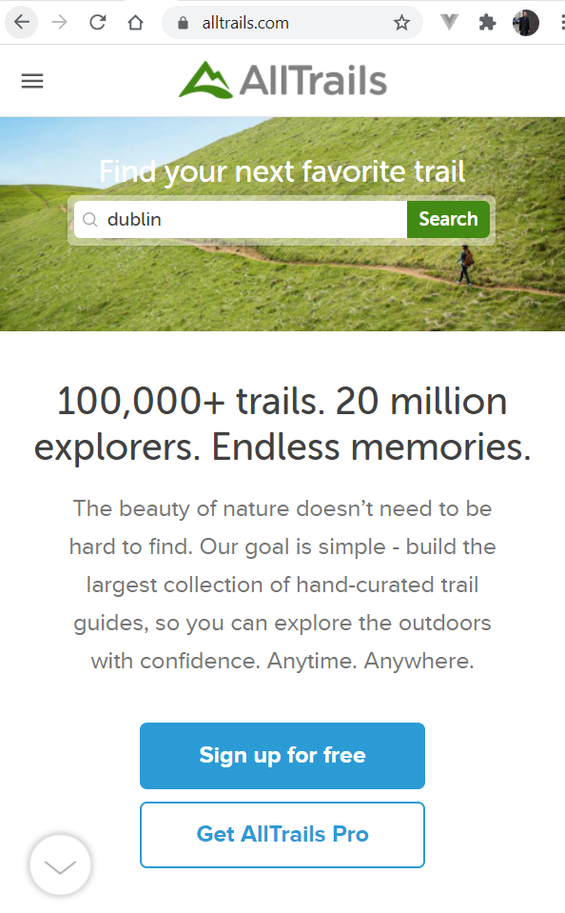
Mobile view of AllTrails

- scenario that you are going to prototype.
- A fitness app for beginners that integrates a stepometer and Maps. Each day it gives you a destination and tell you how many steps it is away and then rewards you when you get to the location
- friends can challenge you and set a trail for you to do
- a map and a daily weather report
- call to action could be "Rob just challenged you to a 5k trail"---Accept Challenge
- integrate with Spotify and play a song when you get to the location
- winner of challenge takes badge off challenger: e,g. rocket boots badge.
- choose the difficulty or length/time of the route you want to do

